|  |  |  |  |  |  |  |
| --- | --- | --- | --- | --- | --- | --- |
| WBS2 | WBS3 | Work package | O/ML/P | PERT effiecient work hours (pay hours)/efficient work days | Resources (% in project/work package) | PERT duration workhours  (pay)/wdays/calender weeks |
| Junior Interface | Application | Job interview  CV  CPR Training | 8/12/18  6/10/16  8/12/18 | 12(18)/3  10(15)/2.5  12(18)/3 | 1 UI/UX designer  1 SW WebDev, BackendDev (Fullstack) | 34 (47) / 8 / 2 (1.5) |
| Senior  Interface |  |  |  |  |  |  |
|  |  |  |  |  |  |  |
|  |  |  |  |  |  |  |
|  |  |  |  |  |  |  |
|  |  |  |  |  |  |  |
|  |  |  |  |  |  |  |
|  |  |  |  |  |  |  |
|  |  |  |  |  |  |  |
|  |  |  |  |  |  |  |
|  |  |  |  |  |  |  |
|  |  |  |  |  |  |  |
|  |  |  |  |  |  |  |
|  |  |  |  |  |  |  |
|  |  |  |  |  |  |  |

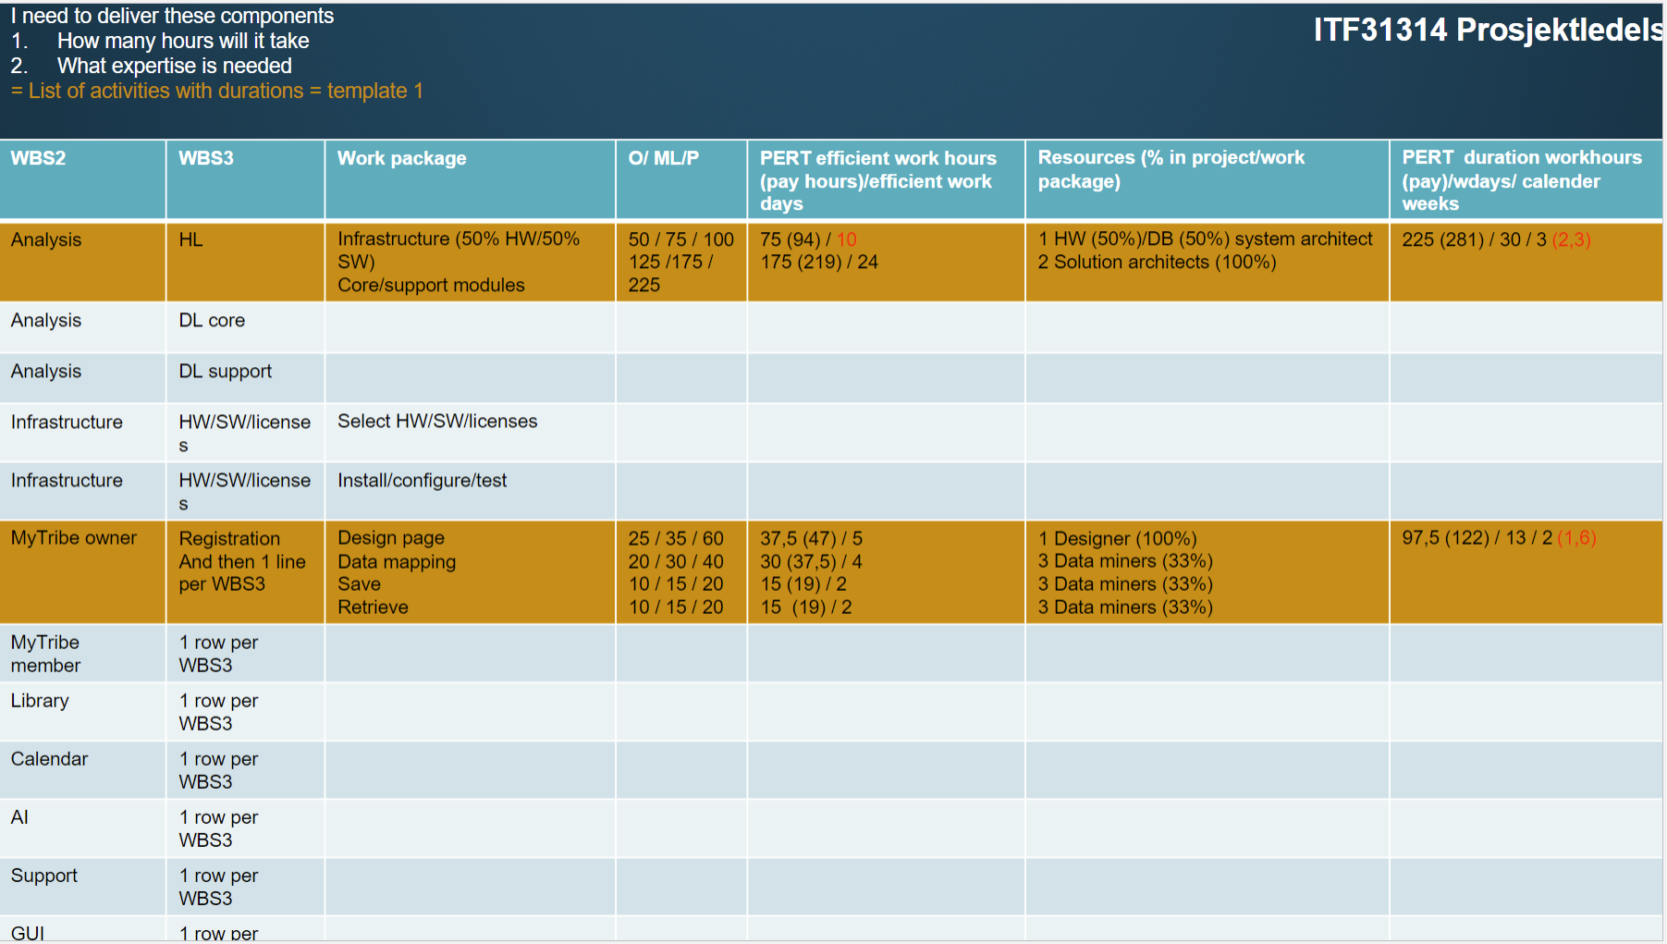 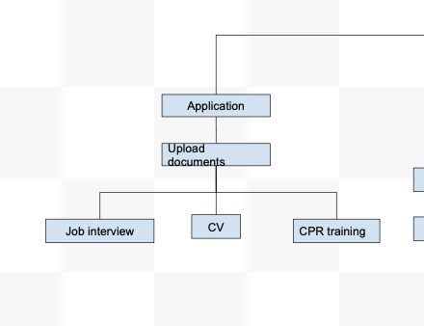

The draft explained:

We (Johan, Trina and Miriam) took just a small part of our WSB (the screenshot of the junior interface detail to the right) to test the work package template. It was a bit complicated and hard to understand, so we needed to create a draft first to try to understand it better. For workhours, we thought a four day work week where you work six hours per day, but you work efficiently for about four hours out of those six hours.